**Memo**

To: Professor Pisano

From: Nick Gutierrez, Seok Young Choi, Eunhye Kwon, Lisa Wei

Team: 24

Date: 03/17/2023

Subject: 2nd Prototype Test Report

1. **Required Materials**

Hardware:

* Adafruit HUZZAH32 Esp32 Feather board
* 1 LiPoly battery
* 8 Capacitive Touch Buttons
* Adafruit MPR121 12-Key Capacitive Touch Sensor Breakout
* 3D printed Controller Casing

Software:

* ESP32 code
  + Reads inputs from touch buttons and maps them to controller inputs which are then sent over Bluetooth to the computer.
* Gamepad HTML tester website
  + <https://gamepad-tester.com/>
* 1 copy of Portal Reloaded to demo in game functionality.

**2.0 Setup**

1. Power the device by flipping the power switch.
2. Press a couple of buttons to verify inputs are being registered.
3. Open the Gamepad Tester site and verify the controller is being picked up.

**3.0 Testing Procedure**

1. Demonstrate how the user’s hands should be placed and joystick mobility.
2. Open the Gamepad testing site and demo each button/joystick corresponding to the correct gamepad output.
3. Open Portal Reloaded and show the controller inputs begin the corresponding action in the game
4. Complete the Lasers level of Portal Reloaded

**4.0 Measurable Criteria**

* Minimal mobility issues when using the palm joysticks and pressing the touch buttons.
* Gamepad testing site shows correct output for controller inputs.
  + Both buttons and joysticks
* Level of Portal Reloaded is demonstrated and completed.

**5.0 ESP Input to Controller Button Mapping**

Table 1: ESP to Controller Button Mapping

| **ESP Button** | **Controller Button** |
| --- | --- |
| Physical Button 1 (BUTTON_0) | Start |
| Physical Button 2 (BUTTON_1) | Select |
| BUTTON_2 | Logo |
| BUTTON_3 | A |
| BUTTON_4 | X |
| BUTTON_5 | LT |
| BUTTON_6 | LB |
| BUTTON_7 | RB |
| BUTTON_8 | RT |
| BUTTON_9 | A |
| BUTTON_10 | B |

**Fig. 1**. Schematic of controller. This controller has an Adafruit HUZZAH32 Esp32 Feather, 8 touch buttons, and two joysticks. Potentiometer and LED lights will be added after further design testing.

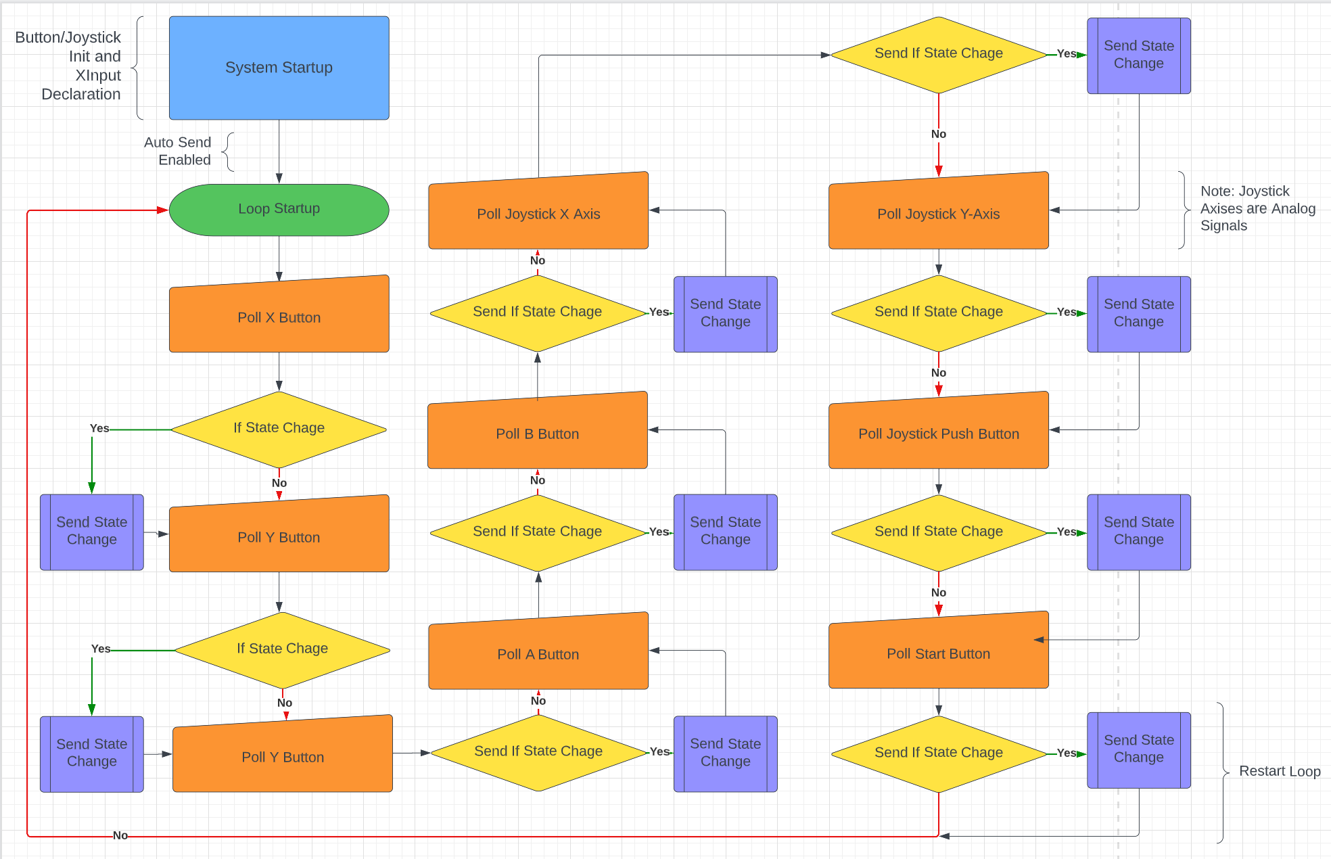

**Fig. 2.** Software Flow Diagram of Controller

**6.0 Score Sheet**

**6.1 Controller Hardware/Software Testing**

**Table 2**: Controller buttons and joysticks testing results. The functionality of buttons and joysticks will be tested through LED outputs, gaming controller outputs, and game action performances.

| Button | Correct Controller Output? | Game Action Performed? | Button Hard to Press? | Total Score |
| --- | --- | --- | --- | --- |
| BUTTON_0 | Yes | Yes | Yes | 60% |
| BUTTON_1 | Yes | Yes | Yes | 60% |
| BUTTON_2 | Yes | Yes | No | 100% |
| BUTTON_3 | Yes | Yes | No | 100% |
| BUTTON_4 | Yes | Yes | No | 100% |
| BUTTON_5 | Yes | Yes | No | 100% |
| BUTTON_6 | Yes | Yes | No | 100% |
| BUTTON_7 | Yes | Yes | No | 100% |
| BUTTON_8 | Yes | Yes | No | 100% |
| BUTTON_9 | Yes | Yes | No | 100% |
| BUTTON_10 | Yes | Yes | No | 100% |

**6.2 Boston Medical Center Rheumatology Department Focus Group Test Results**

We conducted a focus group study at Boston Medical to assess the usability and effectiveness of our video game controller designed for individuals with hand arthritis. The study included 5 Rheumatologists and 10 patients with hand arthritis who were experiencing difficulties using traditional game controllers.

During the study, participants were asked to perform various tasks using our video game controller, such as navigating through a virtual environment and completing simple gameplay actions. Participants were also asked to provide feedback on the comfort, ease of use, and overall effectiveness of the controller.

The results of the study showed that the majority of participants found the joystick easy to use with their palm. However, 60% of participants reported feeling discomfort when their hands were in the rest position due to the height of the joystick and the placement of the buttons. Many participants reported that the horizontal button placement felt unnatural, and they preferred the buttons to be curved to fit the natural curvature of their fingers. Furthermore, participants noted that the high peak on the joystick was uncomfortable, and they would prefer if the joystick was flatter to enable their hands to be relaxed and stretched out.

On a positive note, 86.6% of participants reported that they did not experience any pain or discomfort when using the touch sensor buttons shown in Fig. 3. The study also revealed mixed responses when participants were asked if they could play games with our video game controller for more than 30 minutes. 53.3% of participants said yes, 13.3% of participants felt uncertain, and 33.3% of participants said no.

Forms response chart. Question title: Do you feel any pain or discomfort when using the metal buttons on the controller?

. Number of responses: 15 responses.

Fig. 3. Results indicating that the majority of participants did not feel any pain or discomfort when using touch sensor buttons on the controller. Scale of 1-5 with 1 meaning very comfortable and 5 meaning very uncomfortable.

Overall, the Boston Medical focus group test showed that 60% of participants found our video game controller more comfortable than the standard controller. The study also highlighted several areas for improvement, such as adjusting the height and placement of the joystick and buttons to reduce discomfort during extended gameplay sessions.

**7.0 Conclusion**

After conducting both the prototype test and the Boston Medical focus group test, we have determined that the hardware and software components of the controller are functional and require no further improvements. However, the design of the controller needs more improvement to increase the comfort and usability for individuals with hand arthritis. The results from the focus group test indicated that participants experienced discomfort with the height and placement of the joystick and buttons, which could impact the overall effectiveness of the controller during extended gameplay sessions. The results from the prototype test indicated that two physical buttons were more difficult to press than touch sensor buttons and these might cause discomfort to individuals with hand arthritis. As the next steps of the project, we plan to address these issues by changing the position of the buttons to fit the natural curvature of the fingers and lowering the height of the joystick to ensure that the hand is in a relaxed position. These improvements will be crucial in making the controller more accessible and enjoyable for individuals with hand arthritis.